Request to Allocate Budgeted Funds Instructions

This form is designed to quarantine funds per provider and service area.

Please find attached our participant request to allocate budgeted funds form. This form is designed for Cos who don’t already have their own system in place. If you have your own template please feel free to use that instead. Alternatively, you can send through copies of the Service Agreement with a schedule of supports. We don’t need to sight the Service Agreements if this form has been filled in.
Once we receive this form, we will put your request into our system. The form should be sent to sa@peakplan.com.au

A handy little support calculator can be found at https://www.supportcalculator.com.au/
Note: it doesn’t allow for public holidays, you will need to calculate them separately.

Change of Circumstances

If you need to add or delete funds to/from an existing service booking, this can be done by going to our website.
https://www.peakplanmanagement.com.au/providers/bookings

Instructions
- Open Excel file but save a blank copy before you start.
- Enter participant name, plan dates and NDIS number.
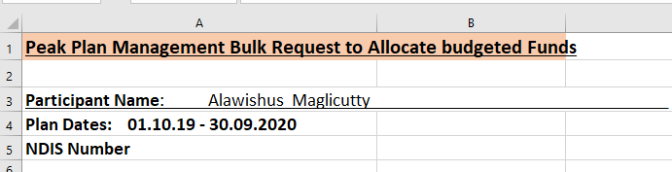

- Enter Provider Name Provider ABN, Area of the Plan e.g., Core Assistance with daily Life etc.
- The NDIS category uses a drop-down list to select. Click in the NDIS category cell and a list will appear for you.

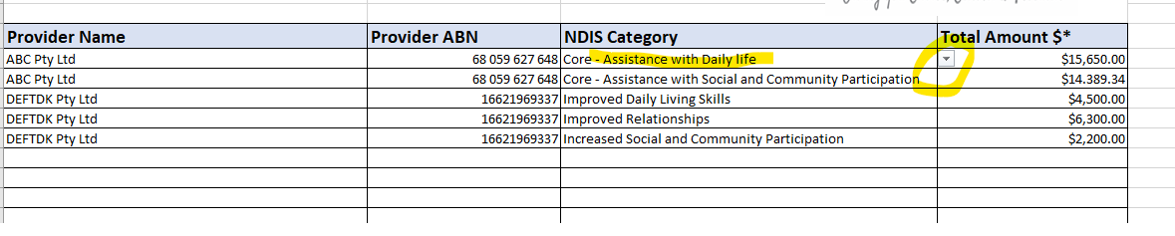
- Enter the total amount per NDIS category. Please note we need the total per the plan not what is left. So if we are halfway through the plan, we need the amount that was originally budgeted or what was signed per the Service Agreement.

